

14 FABRUARY, 2023

dani brenes hidalgo

dam viod

BETS AND DICES

Contenido

ABSTRACT 2

DIAGRAMA DE FLUX 3

code explanation 4

CODI COPIAT 5

HEADER 5

cpp main 5

FUNCTIONS CPP 5

ANNEXOS 9

CONCLUSIÓ 10

## ABSTRACT

This little code is used to simulate a gambling game, that uses 2 values to place a bet, and depending on the result, it gives X times the mount of coins in game.

## DIAGRAMA DE FLUX

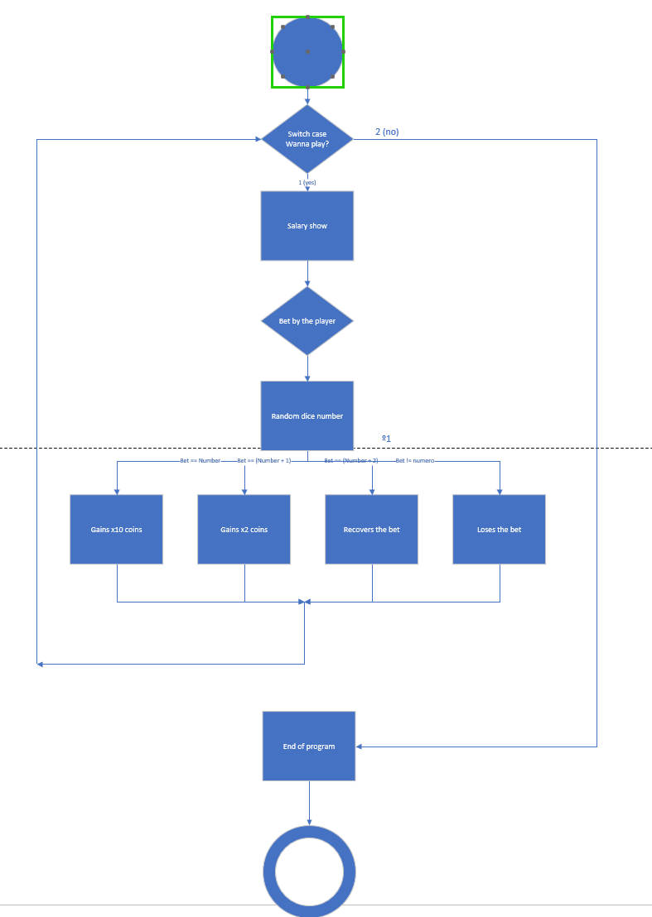

## code explanation

This code works as a simple gambling game, where 2 dices are randomly generated and then it gives you a certain amount of coins based on your bet.

To do this, we created a header with the libraries and functions we’ll use, those that you can check in the next part.

To do the int main, we just declared the random seed and various variables needed for our game. That’s because the functions will work as a chain, making the program possible.

For the function menu, I decided to create a void to keep the game on playing until you stop it, to prevent it to close once you’re finished.

That function is a do-while fused with a switch case, with the condition being that the variable opcio is diferent to 2.

After that, the player will introduce how many coins will bet and then the number he thinks that’ll appear.

With an other function, 2 dices will be randomly generated and using some conditionals, it will give the coins amount stated to the player based on the number given.

## CODI COPIAT

### HEADER

#pragma once

//Libraries used during the code

#include <iostream>

#include <Windows.h>

//Space where the program is displayed

using namespace std;

//Functions used during the program

void gambling(int& aposta, int* cartera, int* numero);

void menu(int opcio, int* cartera);

void tirada(int* dau1, int* dau2);

void resultat(int* total, int* aposta, int& cartera, int* numero);

### cpp main

#include "HeaderDaus.h"

//Main function of the program

int main()

{

//Here we state the main variables used during the program

int opcio = 0;

int cartera = 100;

//Random seed

srand(time(0));

//Function that initates the void that creates the program

menu(opcio, &cartera);

}

### FUNCTIONS CPP

#include "HeaderDaus.h"

/// <summary>

/// This function works as the main connector, to make the player able to decide if he wants to play or not

/// </summary>

/// <param name="opcio"></param> this function will be used to decide if to continue or not

/// <param name="cartera"></param> this is used as a value for the coins that we can use

void menu(int opcio, int* cartera) {

//variables used to generate random numbers

int dau1;

int dau2;

int total;

int aposta;

int numero;

//With this part we create a void that lasts until the value opcio is 2

do {

//We create this do while to avoid the player use unintended options

do {

cout << "Introdueix 1 per fer la teva aposta, 2 per sortir" << endl;

cin >> opcio;

} while (opcio != 1 && opcio != 2);

//This conditions are used

if (opcio == 1 && *cartera > 0) {

dau1 = 0;

dau2 = 0;

total = 0;

aposta = 0;

gambling(aposta, cartera, &numero);

tirada(&dau1, &dau2);

total = dau1 + dau2;

resultat(&total, &aposta, *cartera, &numero);

}

//This part is displayed when the player tries to play but he has 0 coins

else if (opcio == 1 && *cartera <= 0) {

cout << "Fora d'aqui! No et queden calers!" << endl;

return;

}

} while (opcio != 2);

}

/// <summary>

/// Function used to simulate 2 dices giving a number

/// </summary>

/// <param name="dau1"></param> first dice

/// <param name="dau2"></param> second dice

void tirada(int* dau1, int* dau2) {

*dau1 = rand() % 6 + 1;

*dau2 = rand() % 6 + 1;

//This used to display the adress of the info

cout << "El primer dau ha tret: " << *dau1 << endl;

cout << "El segon dau ha tret: " << *dau2 << endl;

}

/// <summary>

/// Function used to make the bet and get it from the pocket salary

/// </summary>

/// <param name="aposta"></param> bet done by the player

/// <param name="cartera"></param> amount of salary that the player has

/// <param name="numero"></param> bet from the player

void gambling(int& aposta, int *cartera, int *numero) {

//Void to avoid the player to introduce an unvalid number

do {

cout << "Introdueix la quantitat a apostar" << endl;

cout << "Salari: " << *cartera << endl;

cin >> aposta;

} while (aposta <= 0);

//Value substracted from the salary value

*cartera -= aposta;

cout << "Introdueix el numero que creus que sortira: " << endl;

cin >> *numero;

}

/// <summary>

/// Function used to give the player the amount of coins based on the result of the bet

/// </summary>

/// <param name="total"></param>

/// <param name="aposta"></param>

/// <param name="cartera"></param>

/// <param name="numero"></param>

void resultat(int* total, int* aposta, int& cartera, int* numero) {

//If the number equals, the bet is multiplied by 10

if (*total == *numero) {

cout << "Has guanyat! Aqui tens 10 vegades el que havies apostat!" << endl;

cartera += (*aposta * 10);

}

//In case the bet is 1 position around, it gives the double amount of the bet

else if (*total == (*numero - 1) || *total == (*numero + 1)) {

cout << "Esta prou be! Per un numero! Guanyes el doble del que has apostat!" << endl;

cartera += (*aposta * 2);

}

//In other hand, if the result is around 2, it gives the user the same amount

else if (*total == (*numero - 2) || *total == (*numero + 2)) {

cout << "Un pel lluny... Pero aqui som benevolents, aixi que et tornem el que has apostat..." << endl;

cartera += *aposta;

}

//Finally, if the number 3 numbers larger or shorter, the user loses his bet

else {

cout << "Bueno, si ja et passes de 3, aqui si que has perdut!" << endl;

}

}

## ANNEXOS

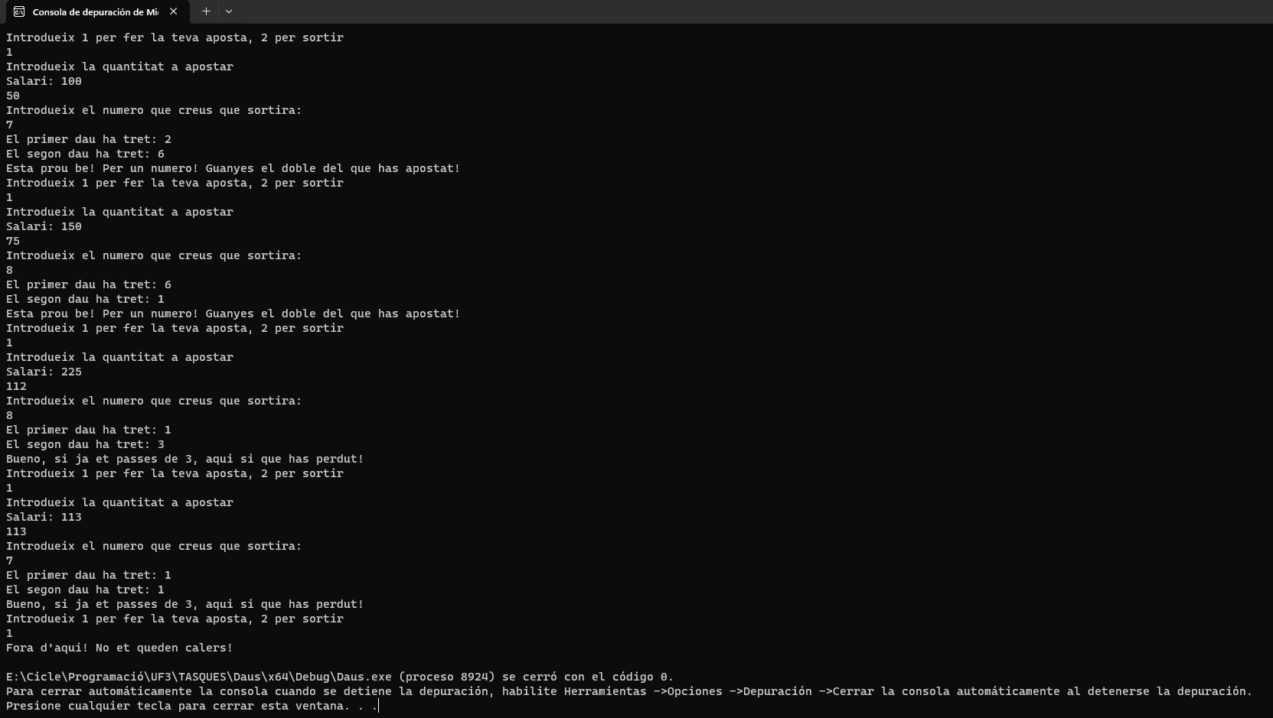

GAME VOID EXEMPLE, PLAYER LOSES ALL HIS COINS AND GETS KICKED FROM THE GAME

## CONCLUSIÓ

This has been certainly a good practice to start learning about calling variables and their values, to be able to know new tools.